Log on to the new Ladok
To log into the new Ladok open a new web page (use Firefox) and enter the address:
https://www.resultat.ladok.se/gui/loggain
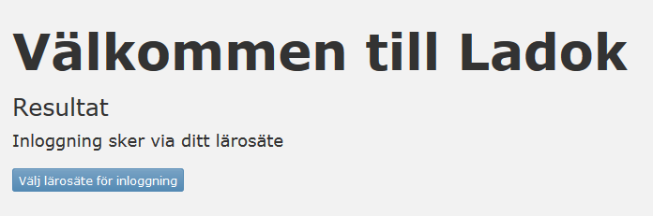
- Choose university to login
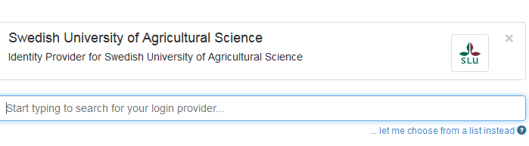
- You can either type Swedish University of Agricultural Science in the text field or choose to search from a list.
- After the first time you have logged in SLU will be default every time you log in
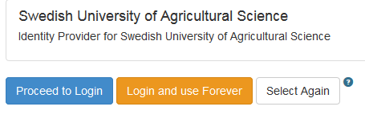
- Make a click on ’Proceed to Login’
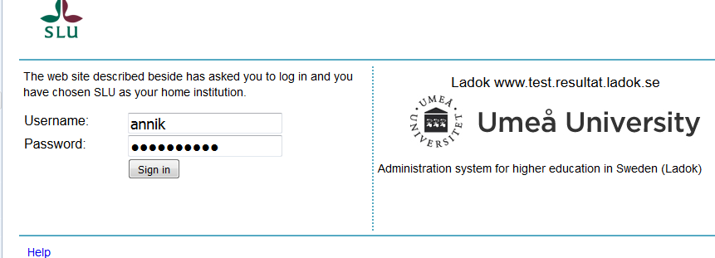
- Enter the username and password. It’s the same password and username as you have when you log on to your computer.
You should now have reached the first page of the new Ladok. If you want the new Ladok in english make a click on the Main menu, general and change language.
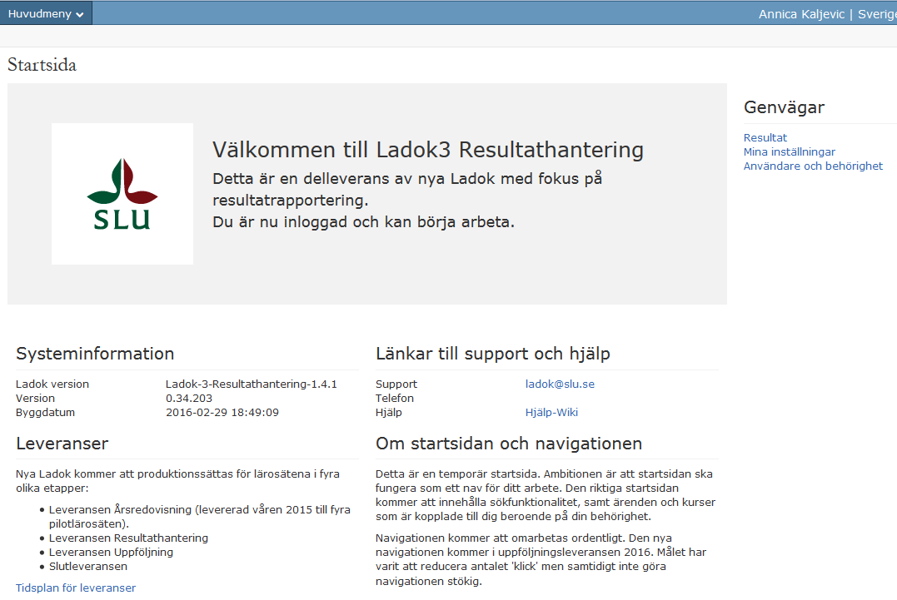

Important!
Do you have a circle standing and spinning, press the F5 button until it says your name and the Swedish University of Agricultural Sciences, at the right corner on the top.