My certifications
When it's time to certify on a course you can choose to go through
- My certifications’ or
- ’Serach course’ or
- ’Search session’
A list of the students who have completed the course are marked for certification is shown. 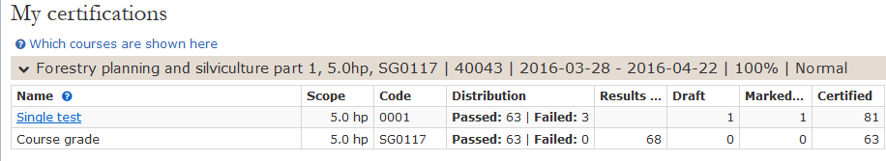
- Should you approve a student, mark the box in front of the current person
- Should everyone be approved, mark the box next to the headline personal identity no.
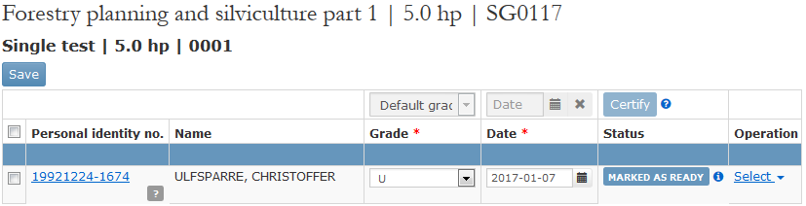
- Enter grades and title if it is a degree project
- You can change the date and grades if needed
- Save
- Make a click on certify and save

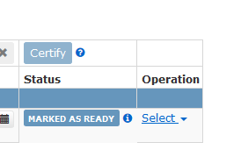w

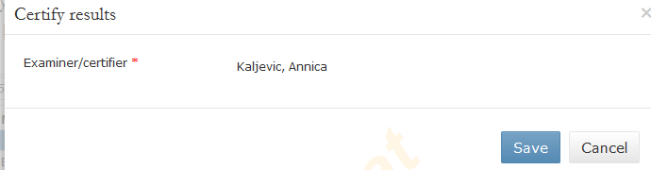

- Once you've done this, you have to log in again as a safety precaution
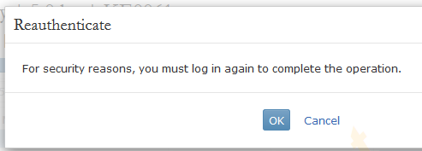

- När detta är gjort kommer kursen att visas igen men utan studenter.
- Då har allt gått bra med inläggningen av resultaten

