Entering results
During My reports the courses you are authorized to enter results on will be listed. The links to these courses remained here for about 12 weeks. If the course is not listed here, you can always search out the course through the 'Search course' or 'Search session'.
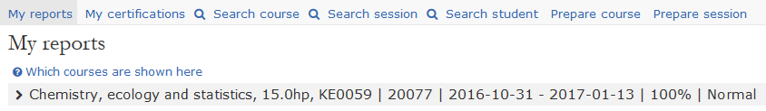
Here is the course KE0059 as an example 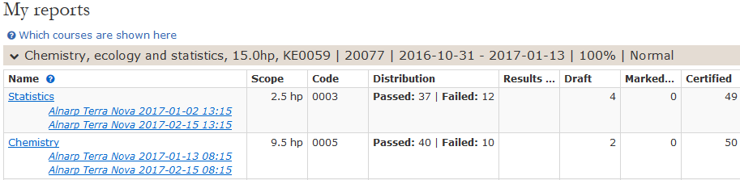
- On the module Statistics will grades be inserted. Click on the link (see arrow), the students are shown that are registered for the course.
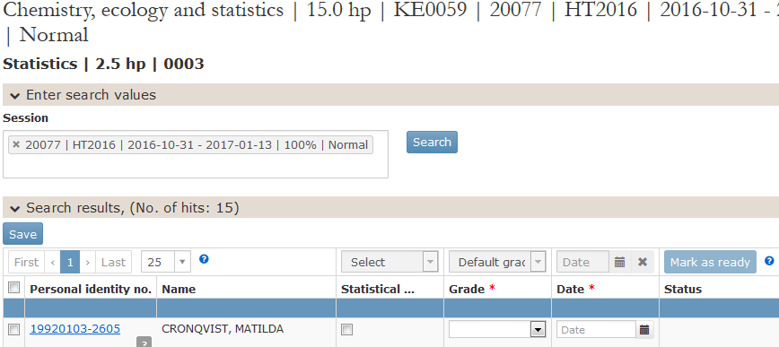
- You can now start adding grades and dates.
- If you mark the box to the left of the heading "Personal identity number" all students will be marked. Then you can work you with all students at the same time.
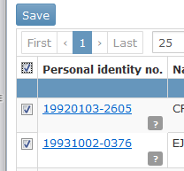
- By selecting 'Default grades and date' the same grades and dates adds for all students.
- Now you can change for the students that should have different grade

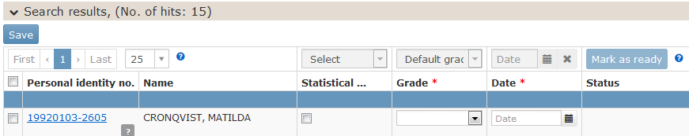
- If you click on Save, you can get back to the list later and continue
- When you click on the mark as ready, you cannot work more with the list.
- An email will now be sent to the examiner indicating that all students are ready for approval.
- The examiner can now make a change or certify (add the results as approved)

