SLU Course Design Tool
Table of contents
Introduction 2
How to use this tool 3
Part 1: Prerequisites 4
1.1 Strategical relevance 4
1.2 Student and target group analysis 5
1.3 Previous course evaluations and student feedback 5
1.4 Administrative information 6
Part 2: Resources 8
2.1 Financial needs and resources, organization, and teaching premises 8
2.2 Support functions at SLU 8
2.3 Teachers and pedagogical skills 9
2.4 Course material to support learning 9
2.5 Digital Educational Infrastructure at SLU 10
Part 3: Pedagogical linchpins and course design 11
3.1 Intended Learning Outcomes 12
3.2 Learning activities and digital alternatives 14
3.3 Teaching activities 15
3.4 Examination 16
3.5 Making the connections visible 17
Checklist 19
About the SLU Program and Course Design Tool project 20

Introduction
The purpose of this course development tool is to support a pedagogical, creative, and structured planning of a course. The tool is intended to help the planning team to reflect upon key course planning aspects and to provide easy access to different kinds of resources, weblinks etc. This tool is not intended for the administrative part of the planning process.
The process of planning a course is, from our experience, best performed when done in a team of teachers, administrative staff, and educational developers.
The main parts of the course planning process are shown in figure 1 below.

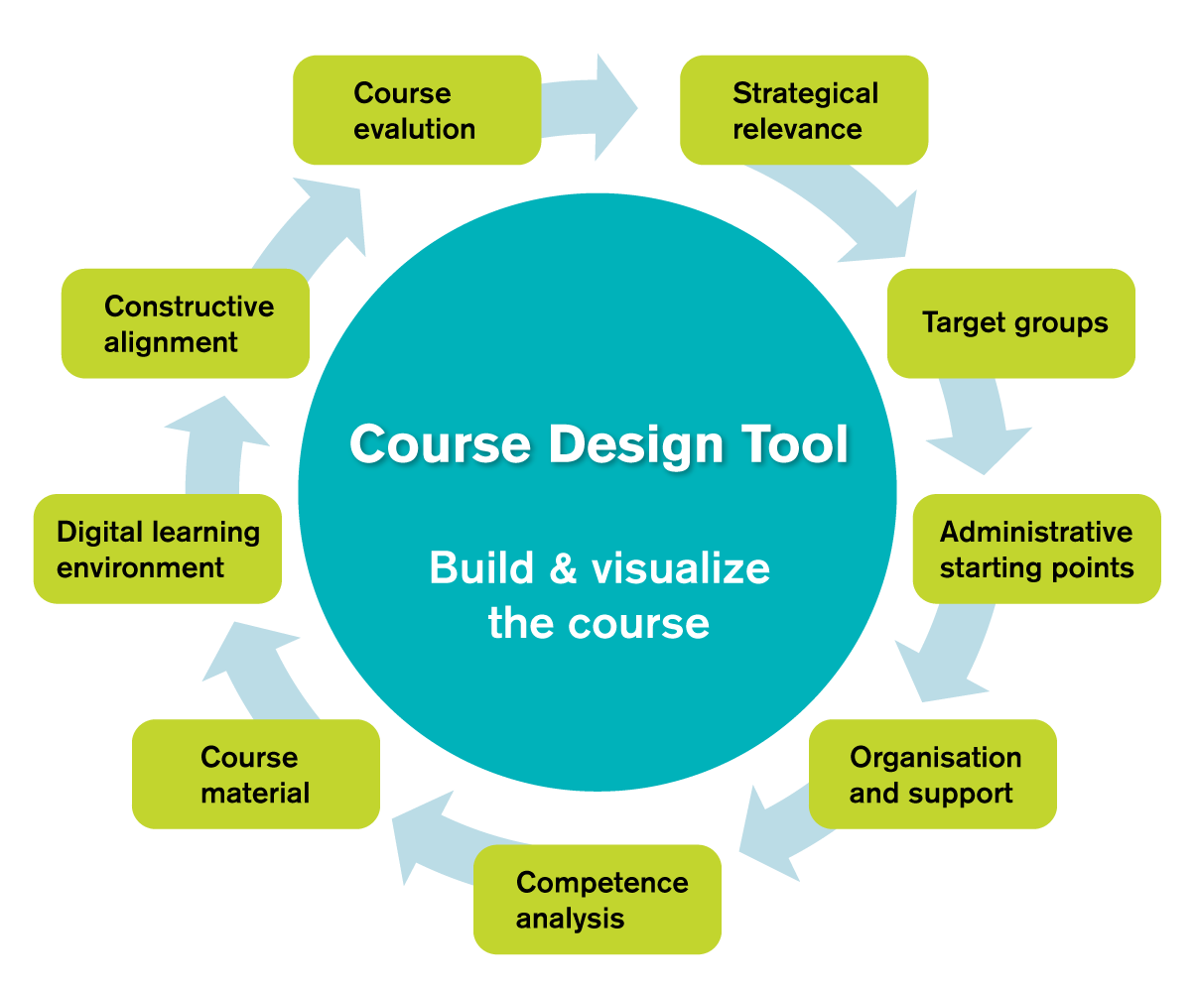

How to use this tool
This document consists of three main sections: prerequisites (1), resources (2), and pedagogical linchpins and course design (3). These sections are organized by a number of questions that touch upon relevant issues concerning each section. You can begin working in any section you wish, but we recommend that you take a look at all three parts of the document to get an overall view of your course.

Each and every question is introduced briefly, followed by an interactive field in which you are able to write notes concerning the question. In each interactive field there is a blue text of instruction (“click or tap here to enter text”, “choose an item” or something similar). When you place your cursor in the field, the text of instruction will be highlighted and you can start writing your ideas into the field. In order to keep the formatting, the text you write should be blue.

The interactive fields in part 3.1 (Intended Learning Outcomes), 3.3 (teaching activities), and 3.4 (assessment tasks) will be directly imported to the table on part 3.5 (making the connections visible), when you update these fields. Follow the instructions above the table in part 3.5.

Important! In order for text in 3.1, 3.3, and 3.4 to be imported to the table in 3.5, all text needs to be written directly into the interactive fields. Do not copy paste text from other documents. If you do, the formatting will be lost and the text will not show in the table in part 3.5.

Below each interactive field is a green box with a set of reminders on the topic at hand. Discuss these reminders with your colleagues, and return to your notes for further revision and development of your course.

This document will grow with your notes. Therefore, you need to update the table of content on the first page for the pages to be shown correctly. Click on the headline (“table of contents”), and the whole table will be highlighted. On the top, above the headline, a menu will appear when you click on the small arrow pointing downwards. Choose “update table of contents”, then choose to update page number, or the whole table of contents. The table of content will be automatically updated. Remember to save the document frequently.

Final note from the project group: The development of this tool is a work in process. Please do not change any text or image outside of the notes you write the interactive fields.

Part 1: Prerequisites

1.1 Strategical relevance
SLU is recognized as a prestigious university in several international university rankings. One of the missions of SLU is to offer programs and courses that provide the knowledge and skills for a sustainable future generation. Strategic planning at SLU is one of the means of addressing the global challenges of today. In order to frame the connections between the societal needs of the course, identify and describe the connections of your course in relation to the overarching visions and strategies below. Finish your planning by looking back on your survey using the questions in the green box.
Agenda 2030
Click or tap here to enter text.
Societal needs
Click or tap here to enter text.
Labor market needs
Click or tap here to enter text.
SLU's strategy
Click or tap here to enter text.
Faculty strategy
Click or tap here to enter text.
Other
Click or tap here to enter text.
Looking back at the identified connections:
- Why is the course needed from a societal perspective?
- Are there similar courses at SLU or at other universities?
- What does the labor market say? How does the course reflect the need of the labor market?
- What do other stakeholders say about the needs for this course?

1.2 Student and target group analysis
Think about which students might be interested in the course, what language they speak, where they are from, and what needs they may have in regards to the education. It is also important to consider the necessary qualifications to be able to fulfill the requirements of the course. Finally, a survey of the intended target group should also indicate which other target groups we might have overlooked. Describe the course conditions regarding the above in the field below and finish by looking back on your descriptions using the questions in the green box.
Describe the presumed students
Click or tap here to enter text.
Looking back at the description:
- What countries or regions do the students come from? What does this say about their educational experience, background and expectations?
- What language(s) do they speak?
- How can you reach them in the best way?
- What are the necessary qualifications for the studies required in the course?
- Which knowledge and education/work life experiences, knowledges might they bring with them from other contexts?
- Are any of the qualifications mentioned above negotiable for the benefit of reaching a larger pool of students?

1.3 Previous course evaluations and student feedback
Consider previous evaluations of similar courses. What are the strengths and weaknesses of these courses? How could your investigation be helpful in planning this course? In addition to that, alumni could be a great resource in identifying advantages and areas of improvement. Describe various conditions of the course as well as the identified needs and areas of development in the field below. Consider in particular how the process of planning, implementation, follow-up and further development can be organized in relation to this.
Describe the areas of development in regards to previous course evaluations and student feedback:
Click or tap here to enter text.

1.4 Administrative information
Select the relevant key administrative information for the course. With this in mind, think about the different teaching formats in the green box below. In what way would they serve the students in the best possible way? If the course is part of a program, how does it relate to other courses and to the program as a whole?

Part of a program: | Choose an item.
Course level: | Choose an item.
Campus/Distance: | Choose an item.
Language: | Choose an item.
The course is approved: | Choose an item.
Credits (HP): | Choose an item.  Credits if other: Click or tap here to enter text. credits
Academic year/Semester/Period: | Click or tap here to enter text.
Study pace: | Choose an item.  If other: Click or tap here to enter text. %
Subjects: | Click or tap here to enter text.
Department: | Click or tap here to enter text.
Instructional time: | Click or tap here to enter text.

Reflect on the type of teaching format that would serve the students in the best possible way:
- Campus?
- Multi-Campus?
- Distance/Blended?
- Full time/Part time?
- Study pace?

Part 2: Resources

2.1 Financial needs and resources, organization, and teaching premises
Consider which financial and organizational resources are required to launch the intended course. Collaboration between different courses could be an option for economically viable alternatives. Furthermore, there should be a well-functioning administrative team as well as a body of teachers that has the necessary disciplinary expertise and pedagogical skills. Finally, there needs to be sufficient awareness about any specific requirements concerning teaching premises.
Describe your resource needs regarding the aspects above in the field below and finish by looking back at your text using the questions in the green box.
Click or tap here to enter text.

What does our description tell us about:
- Financial resources?
- Collaboration between several different courses?
- Administrative support?
- Teacher teams?
- Are there any special needs concerning teaching premises?

2.2 Support functions at SLU
The university administration supports and provides service for the university’s education (see the delegation of authority for the university administration). Below, you find links to some of the important support functions at SLU that are available for you as a course developer:
Division of Communication
Division of Educational Affairs
Division of IT (AV-support, IT-support)
Division of Learning and Digitalisation (Educational developers, Educational systems, Educational Media)
Division of Real Estate Management
Division of Services, Security and Environment
SLU Library

2.3 Teachers and pedagogical skills
The foundation of good teaching is having a collective of teachers with profound content knowledge and pedagogical skills. Reflect upon which current competencies you have in your department and how the quality of teaching could benefit from them. It may also be relevant to consider specific competencies in certain areas of interest outside the department.
Describe the competences regarding content knowledge and pedagogical skills that are required in the course in the field below, and conclude by looking back at your description using the questions in the green box.
Click or tap here to enter text.
What does our description tell us about:
- Current competencies regarding content knowledge and pedagogical skills?
- Any needs of professional development?
- Expertise in specific areas of interest outside of the department?

2.4 Course material to support learning
Course material involves course literature, equipment for laboratory lessons, and equipment for field studies. In addition to this, course material includes different kind of software, polls, open learning resources, podcasts, audio files, video etc. Think about what kind of course material that could facilitate students’ learning in the course.
Describe what kind of course material you need in the course.
Click or tap here to enter text.
Reflection:
- Is it possible to include more digital resources?
- Are we using open learning resources?
- Are we in need of any specific software?
- What kind of media support do we need?

2.5 Digital Educational Infrastructure at SLU
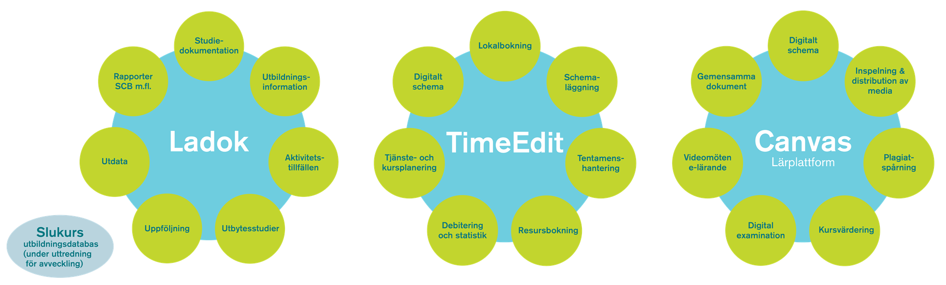

Describe what you intend to use and might need support with, courses, etc.
Click or tap here to enter text.

Part 3: Pedagogical linchpins and course design
SLU takes the model of Constructive Alignment (CA) as a point of departure in developing courses and designing teaching. This means to adhere to an approach to teaching and learning where examination tasks and the learning activities in a course are linked to the specific Intended Learning Outcomes (ILOs) in the syllabus. The activities and examination are closely linked to which knowledge and skills the students should be able to demonstrate after the course completion.
The tool emphasizes the importance of student-active teaching activities and takes CA as a point of departure. There are two basic concepts behind Constructive Alignment:
- Learners construct meaning from what they do to learn.
- The teacher makes a planned alignment between the learning activities, the ILOs, and the assessment.
Constructive alignment
(Biggs, 2003)
How can the teaching and learning activities help the student perform successfully in the assessments?

In what way do these assessment tasks help
the student to achieve the ILOs?

Which methods are suitable
for developing knowledges
and skills in relation to the ILOs?
Heading in course syllabus:
- Students previous knowledge and qualifications?
- Teaching methods
Heading in course syllabus:
- Purpose and intended learning outcomes.
- Subject content?
- Skills?
Heading in course syllabus:
- Formats and requirements for examination
- Assessment tasks
Intended Learning Outcomes
Teaching
activities
Examination

3.1 Intended Learning Outcomes
Courses within programs should be interrelated and together lead to the achievement of specific program qualifications as well as the program’s intended learning outcomes of the educational plan. The ILOs for each course should be developed in accordance with the position of the course within the program and consider the progression of content knowledge as well as the progression of generic skills throughout the program.
In addition to this, overall aspects such as integrating research into teaching, internationalization, gender equality, education for sustainable development, digitalization and digital competence, as well as collaboration with the surrounding community should be taken into consideration both regarding the content of the course and the design of the teaching. To learn more about these aspects, follow this link:
https://internt.slu.se/stod-service/utbildning/pedagogiskt-och-digitalt-stod/undervisa-online---beredskap-for-covid-19/program-kurs-utvecklingsverktyg/

Remember the instructions concerning formatting. See under headline “How to use this tool” on p. 3.

Intended learning outcomes
Intended learning outcome 1 | Click or tap here to enter text.
Intended learning outcome 2 | Click or tap here to enter text.
Intended learning outcome 3 | Click or tap here to enter text.
Intended learning outcome 4 | Click or tap here to enter text.
Intended learning outcome 5 | Click or tap here to enter text.
Intended learning outcome 6 | Click or tap here to enter text.
Intended learning outcome 7 | Click or tap here to enter text.
Intended learning outcome 8 | Click or tap here to enter text.
Intended learning outcome 9 | Click or tap here to enter text.
Intended learning outcome 10 | Click or tap here to enter text.

Is our framing of the intended learning outcomes clear concerning the following aspects?
- We have taken a student perspective into consideration.
- Each ILO should describe what the student is expected to demonstrate after course completion.
- Each ILO should be able to be observed and assessed.
- Each ILO should be clear and easy for prospective students, teachers, and the examiner to understand.
- The content knowledge is connected to the overall aspects and generic competencies.

3.2 Learning activities and digital alternatives

Activities | Do we need in-person activities? |  |  |  | Digital alternatives
 | Must (M) | Should (S) | Could (C) | Won’t (W)
Teambuilding | ☐ | ☐ | ☐ | ☐ | Canvas, Chat, Zoom, Microsoft Teams
Lab | ☐ | ☐ | ☐ | ☐ | Virtual lab, Recorded labs
Discussions | ☐ | ☐ | ☐ | ☐ | Asynchronous / Synchronous communication, Canvas, Chat, Zoom, Microsoft Teams
Lectures | ☐ | ☐ | ☐ | ☐ | Streamed lectures, Recorded lectures, Flipped Classroom
Feedback | ☐ | ☐ | ☐ | ☐ | Via Canvas, Chat, Zoom, Microsoft Teams
Seminars | ☐ | ☐ | ☐ | ☐ | Webinars in Zoom
Group work | ☐ | ☐ | ☐ | ☐ | Canvas, Zoom and ”breakout-rooms”
Study visits | ☐ | ☐ | ☐ | ☐ | Recorded material discussed in Zoom
Field studies | ☐ | ☐ | ☐ | ☐ | Recorded video/streamed video plus discussions
Presentations | ☐ | ☐ | ☐ | ☐ | Digital presentation (Canvas, Zoom, Videoblog, Podcast)
Role play | ☐ | ☐ | ☐ | ☐ | Role play using e.g. Zoom
Poster presentation | ☐ | ☐ | ☐ | ☐ | Digital poster session, e-posters
Other … | ☐ | ☐ | ☐ | ☐ | Click or tap here to enter text.

3.3 Teaching activities
The teaching activities need to provide good opportunities for the students to acquire content knowledge and practice the skills required to achieve specific qualifications of the program. The learning activities also need to prepare the students for the different examination formats. Furthermore, at SLU all teaching strives to foster active student participation. All teaching should be as inclusive and accessible to as many students as possible. It is particularly important to consider students with special physical or intellectual needs and variations.

Remember the instructions concerning formatting. See under headline “How to use this tool” on p. 3.
Teaching activities
Teaching activity 1 | Click or tap here to enter text.
Teaching activity 2 | Click or tap here to enter text.
Teaching activity 3 | Click or tap here to enter text.
Teaching activity 4 | Click or tap here to enter text.
Teaching activity 5 | Click or tap here to enter text.
Teaching activity 6 | Click or tap here to enter text.
Teaching activity 7 | Click or tap here to enter text.
Teaching activity 8 | Click or tap here to enter text.
Teaching activity 9 | Click or tap here to enter text.
Teaching activity 10 | Click or tap here to enter text.

Is our plan for teaching activities clear concerning the following aspects?
- Describes which different kinds of activities are planned.
- The activities encourage active student participation.
- The activities will help the students to pass the examination.
- The activities are linked to the ILOs.

3.4 Examination
Examination is an opportunity to assess, evaluate, and learn. A variety of examination formats is positive because diverse examination forms give students the opportunity to show a range of knowledge and skills. No matter if it is a written or oral examination, it is important that the methods of examination are suitable for the specific course objectives and learning activities. Although developed descriptions of grading criteria are not included in the syllabus, the specific knowledge requirements and descriptions of skills should be considered in planning the examinations within a course.

Remember the instructions concerning formatting. See under headline “How to use this tool” on p. 3.
Assessment tasks
Assessment task 1 | Click or tap here to enter text.
Assessment task 2 | Click or tap here to enter text.
Assessment task 3 | Click or tap here to enter text.
Assessment task 4 | Click or tap here to enter text.
Assessment task 5 | Click or tap here to enter text.
Assessment task 6 | Click or tap here to enter text.
Assessment task 7 | Click or tap here to enter text.
Assessment task 8 | Click or tap here to enter text.
Assessment task 9 | Click or tap here to enter text.
Assessment task 10 | Click or tap here to enter text.

In order to more clearly identify a progression in both designing exams and grading criteria, it is important to consider the verbs used to describe the knowledge and skills required in the examination. Bloom's taxonomy of thinking skills could be helpful in describing a progression in the expected learning of the student.
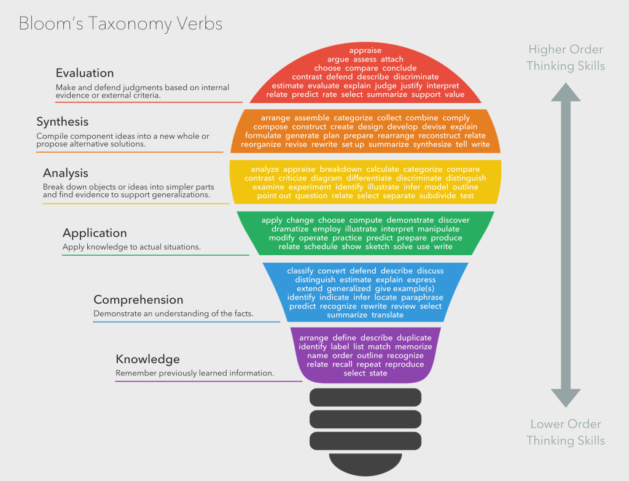
https://commons.wikimedia.org/wiki/File:Bloom’s_Taxonomy_Verbs.png

3.5 Making the connections visible
In order for this particular table to show what you have written in the tables above concerning ILOs, teaching activities, and examination, you need to update each field.
- Right-click on every cell in the table of content and select “Update Field” in the pop-up menu.
 | Intended learning outcomes | Teaching activities | Assessment tasks
1 | Click or tap here to enter text. | Click or tap here to enter text. | Click or tap here to enter text.
2 | Click or tap here to enter text. | Click or tap here to enter text. | Click or tap here to enter text.
3 | Click or tap here to enter text. | Click or tap here to enter text. | Click or tap here to enter text.
4 | Click or tap here to enter text. | Click or tap here to enter text. | Click or tap here to enter text.
5 | Click or tap here to enter text. | Click or tap here to enter text. | Click or tap here to enter text.
6 | Click or tap here to enter text. | Click or tap here to enter text. | Click or tap here to enter text.
7 | Click or tap here to enter text. | Click or tap here to enter text. | Click or tap here to enter text.
8 | Click or tap here to enter text. | Click or tap here to enter text. | Click or tap here to enter text.
9 | Click or tap here to enter text. | Click or tap here to enter text. | Click or tap here to enter text.
10 | Click or tap here to enter text. | Click or tap here to enter text. | Click or tap here to enter text.

Checklist
- Are the connections to the overarching strategies, needs in society and demands from the labor market taken into consideration?
- What do the prerequisites look like concerning?
  - Students and target groups
  - Financial prerequisites, organization, and teaching premises
  - Disciplinary expertise and pedagogical skills
- Is the overarching sustainability approach clearly stated?
- Are digital resources utilized?
- Are the Intended Learning Outcomes (ILOs) clear?
- Do the teaching and learning methods strive for active student participation?
- Is the examination an opportunity to learn, and is progression in the examination form evident?
- Are the ILOs linked together with teaching activities and examination methods?
- Is there a plan for following up on course evaluations?

About the SLU Program and Course Design Tool project
In 2019, the Division of Learning and Digitalisation received funding from the UN to develop a web-based tool to support program and course development. The program development tool is influenced by the CDIO initiative among others.
The inspiration of the course development tool has been two earlier web-tools previously developed at the Division of Learning and Digitalisation. (the projects were funded by NSHU, see e.g
http://www.kursutveckling.se/ http://pervenio.ucl.slu.se/kummel/kummel_demo_content.html).
This first draft (word version) of the course development tool will be available as a web-based fully interactive tool later on.

Project group for the course development tool:
Roger Pettersson, Head of Division
Division of Learning and Digitalisation
Linn Areskoug, Educational Development Officer
Educational Development Unit (EPU), Division of Learning and Digitalisation
Cecilia Almlöv, Head of Unit
Educational Development Unit (EPU), Division of Learning and Digitalisation
Peter Lindberg, Multimedia Developer
Unit for Educational Support Systems and Media, Division of Learning and Digitalisation

