Examination order for SLU at Umeå University
Order examination seats in TimeEdit Exam: https://exam.timeedit.com
You still order special aids through the web form: http://www.printomediatest.service.umu.se/skrivningssalar/bestallning-av-sarskilda-hjalpmedel/

Manual for requesting exams in TimeEdit (TE) Exam
- Log in to TE Exam.

- To come to the exam request, click on Overview of the Exams - the two squares on the left.

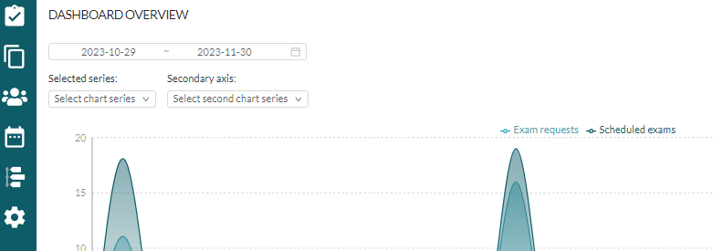

- Hover your mouse over the Actions button at the top right and then click on Create a new exam request.

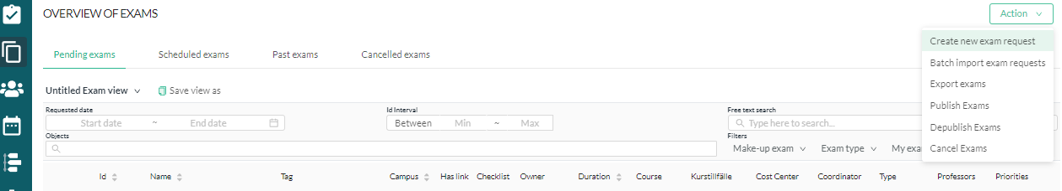

- You are now in the view for the actual exam request:
Fill in the Exam Title. Name the order with the course code and course name/module name.
Fill in the Planned number of students, the Number of hours/minutes the exam should last, and whether it's an Ordinary or Reexamination
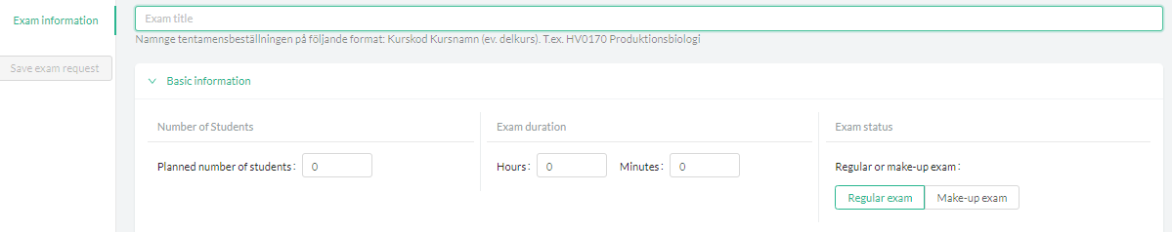

To fill in scheduling preferences, click Create twice. You must specify at least TWO different dates. For each date, indicate if you prefer morning, afternoon, or all day. All day means that either morning or afternoon is acceptable.
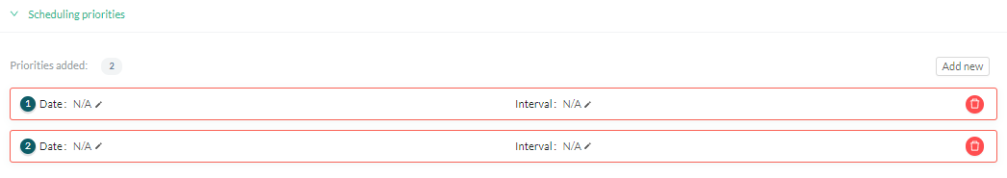

If you are putting in a request for a specific Wednesday afternoon as determined by SLU, specify a Sunday as the second option. This provides a note to the Examination Service at Umeå University that Wednesday is a fixed date. Note! This can only be used for these Wednesday afternoons. Also, clarify this further in Information to the Administrator.
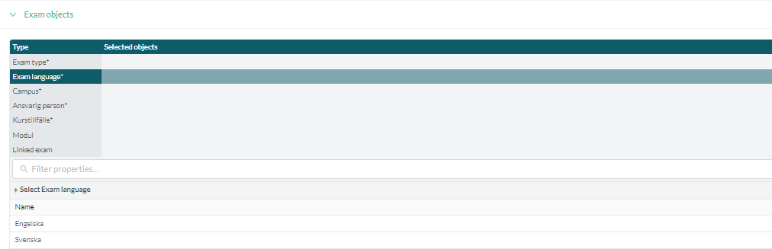
Under Exam Objects, select Exam type, Exam Language, Teacher, Course Occurrence, and Organizational Unit. You make your selection by clicking on the appropriate type in the list below the search box. It automatically proceeds to the next choice.

Teacher: SLU's teachers are not in the system. You should enter TSOBJEKT1. This leaves the teacher field empty.
Course Occurrence: Here you use SLU and the numbers that belong to your institution, e.g., SLU210 for the Forestry School. This makes the course name SLU Exam and the name of the institution.
Organizational Unit: Here you write TENTAMEN_SLU.
Under Additional Information, fill in External Reference and Information to the Administrators:
External reference: Enter your invoice reference, e.g., ABM123.
Administrator Information: Fill in important information that the Examination Service at Umeå University needs to be aware of, e.g., if there is a specific date that must be used.

When everything is filled in, scroll to the top of the page and click Save Exam Order. If it's still gray, it means that mandatory information is missing
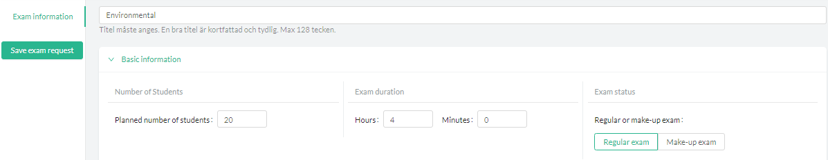

Now the order is complete, and the Examination Service can see it in TE Exam. You can follow the scheduling on the Overview of the exams page (the two squares to the left).
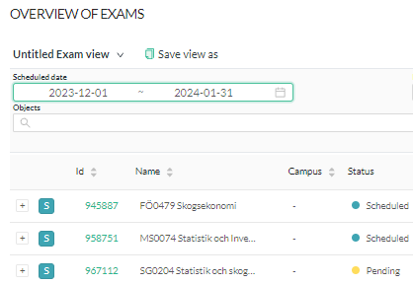

If there is a yellow mark under the status heading, the order is placed but not yet processed by the Examination Service. A green mark indicates that it is scheduled. Red stands for a canceled exam request.
___________________________________________________________________________
Copy a previous order
If you want to avoid filling in everything for each order, you can copy a previously placed order to use as a template.
1. Go to Overview Exam (the two squares on the left). Find the order you want to copy.

2. In the Actions column, click on the dots to open the menu. Select Copy Exam.

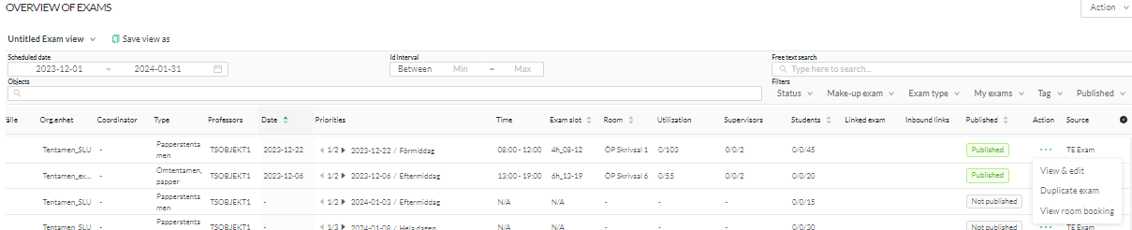

3. Check Comments and Make me the owner. Then click OK to save the copied order

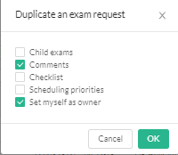

4. The new order now appears in Overview Exam. Open the copied order by clicking on the numbers in the ID column

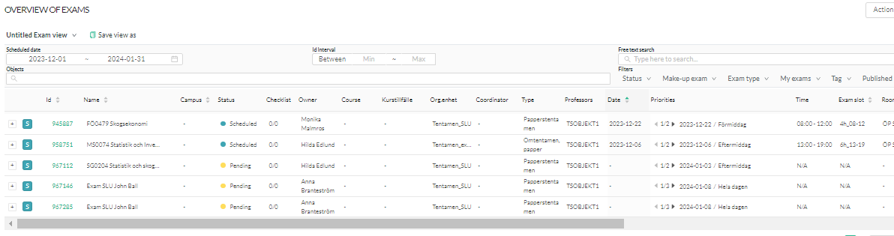
5. Add new date preferences and any other corrections. Then press Save in the upper right corner.
