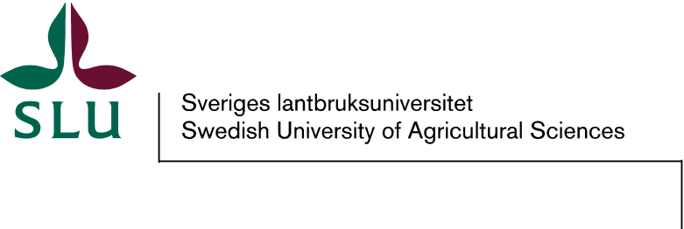
Diarie nr

Memorandum of Understanding
between
[the Department of XXX / the Faculty of XXX / The Swedish University of Agricultural Sciences]
and
[XXX]

Background
Intent of document
This Memorandum of Understanding (MoU) formulates the framework for cooperation between [XXX] and [XXX] within the areas stated below, without inferring any legally binding obligations.
Areas of cooperation
The above parties will cooperate within the fields of [XXX].
Types of activities
[XXX].
Organisation
[XXX]
Model of cooperation
[XXX]
?Financing?
[XXX]
Duration
This MoU will become effective upon its signing and is valid for a period of [XXX] years.

SIGNATURES

Date: Date:
[Name of Institution] [Name of Institution]
[Name, title and affiliation of person] [Name, title and affiliation of person]

_____________________________ _____________________________

