Travel Claims: Quick Guide for Certifier
An e-mail will be received regarding an authorisation via Primula web. This constitutes that a travel claim has been sent from the designated Support to the certifier.

You are tasked to authorise if there is a figure next to Administer OTHER.

If you wish to browse tasks, use the green arrows or the scrollbar.
The complete guide can be found under ?
The traveller may have filled in information in the highlighted blue areas.

- The certifier approves that the travel in question had been warranted
- The purpose of the trip to our locations should be stated
- To gain a quick overview of the costs, click on View/Print
Clicking on Calculate also shows the different subsistence allowances, as well as posting.
To approve the travel claim you highlight ”Approved” and ”Received”. If the travel claim has multiple cost centres it goes first to those Certifiers who have approved their own parts, after which the travel claim goes directly into the Primulus payment system and is paid out with the next monthly salary.

If you wish to reject the travel claim, highlight ”Not Approved” and ”Received”. Write in Message/Appendix the reason for not approving the travel claim.

Since the traveller is not automatically notified that you have rejected the travel claim you should send a separate e-mail stating as such.
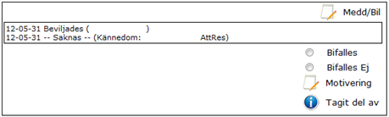

Please submit any questions to your payroll administrator.

