UNIT4
Unit4 ERP Web
Registering time

Content
ERP Web - Primula 3
Overtime and compensatory leave 3
Changed working hours in % – parental leave or partial leave of absence 3
Logging in 3
The ERP structure 5
Menus and submenus 7
Multiple tabs 9
Your timesheet explained 10
Working hours 12
Register time 12
Time codes 13
Project/Work order 13
Activity 13
Cost centre 13
Time unit 13
Time report status 13
Saving the time report 14
Flexitime 14
Approval 14
Create a weekly report template 14
Copy an existing report 15
Rejected report 15
Types of hours 15
Normal working hours 15
Absence (not comp leave) 15
Department of Aquatic Resources 16
Other departments 16
Comp leave 16
Overtime/Additional hours 17
Flexitime 17
Standard reimbursement (only for the Department of Aquatic Resources) 18

ERP Web - Primula

Overtime and compensatory leave
When you register overtime or add hours, standard (schablon) hours (only dep 135) or comp leave you must use special time codes, see the section “Time codes” below.
- These hours are transferred to Primula once a week (once they have been approved).
- You should NEVER register these hours in Primula, only in ERP Web.
NOTE! All other absences must be registered in Primula self-service, see the section "Types of hours" below.

Changed working hours in % – parental leave or partial leave of absence
There is no connection between Primula and ERP Web regarding your working hours.
This means that if you are going to be on full or partial parental leave or leave of absence, you must register this in both systems, Primula and ERP Web. This only applies if the leave covers a longer period of time, not if it is only for a day or two.
If the total number of working hours is not registered correctly in ERP, your flexitime will be incorrectly calculated. Therefore, it is important that you notify your administrator of changes in your working hours before they become effective.

Logging in
You reach ERP Web from Tools and systems on the starting page of the staff web.

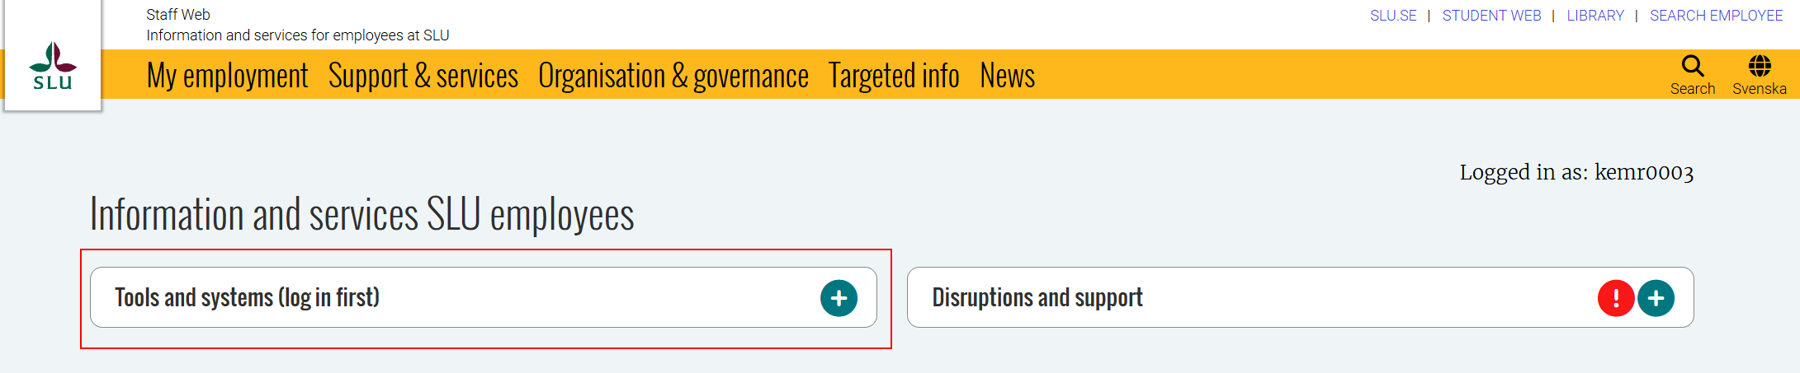
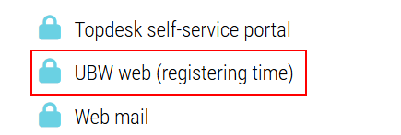
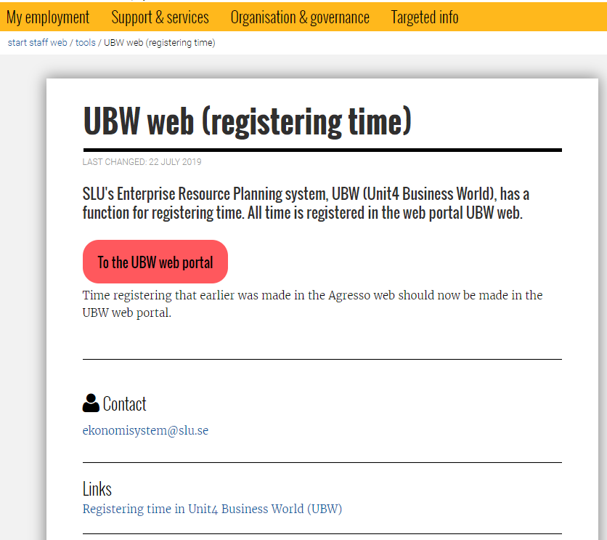
The button “Registering Time” will take you to ERP web, where you are automatically logged on with your ad-account. If you are not connected to SLU network you need to connect with VPN to be able to log on. The links below will take you to the manual “Registering time” and all the E-guides.

The ERP structure
When you have logged in, you will see this ERP screen.
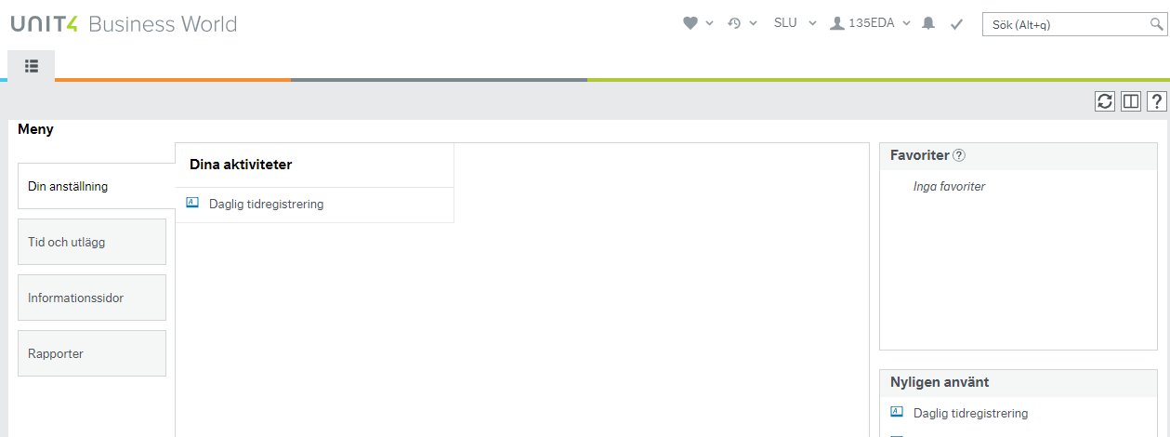

In the left column, you can see all the menu buttons you have access to.
In the middle, you can see the submenus you have access to. When you log in, the first page to be displayed is always "Your employment", unless you have created your own start page.
How to create your own start page is explained in the guide, Create your own Homepage in ERP Web http://www.guider.nu/slu/481.guide.

The upper section on the right shows the pages you have marked as your favourites. How to create a favourite is explained in the guide Where to register time http://www.guider.nu/slu/479.guide.
The bottom section on the right shows the pages you have used recently.
In the top right corner you will see this menu bar:
- Under the heart, you see your favourite pages.
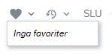
- Under the clock, you see all the pages used recently.
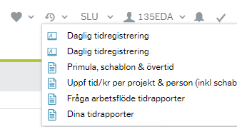

-  Shows who is logged in. Click here to display the logout option and Your profile.
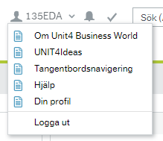

- Under Your profile you can choose your own home page, se the guide Create your own Homepage in ERP Web http://www.guider.nu/slu/481.guide.

- If you have timesheets to process (rejected or for approval) you will see a figure beside the tick mark.
 = no timesheets to process  = 54 timesheets to process

Menus and submenus

Your employment
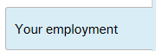 | 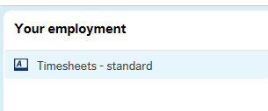

Under the menu Your employment you can access Timesheets – standard, where you register time.

Time and expenses
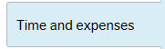 | 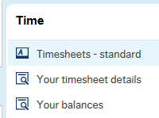

Under the menu Time and expenses you will find:
- Timesheets – standard, where your manager can see all employees' registration
- Your timesheet
- Your balances: flex, comp and standard (schablon)
Information pages
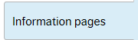 | 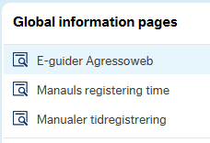
Under the menu Information pages you will find:
- E-guides related to time registration, provided that your browser allows mixed content. See the guide To get to e-guides from ERP Web http://www.guider.nu/slu/478.guide
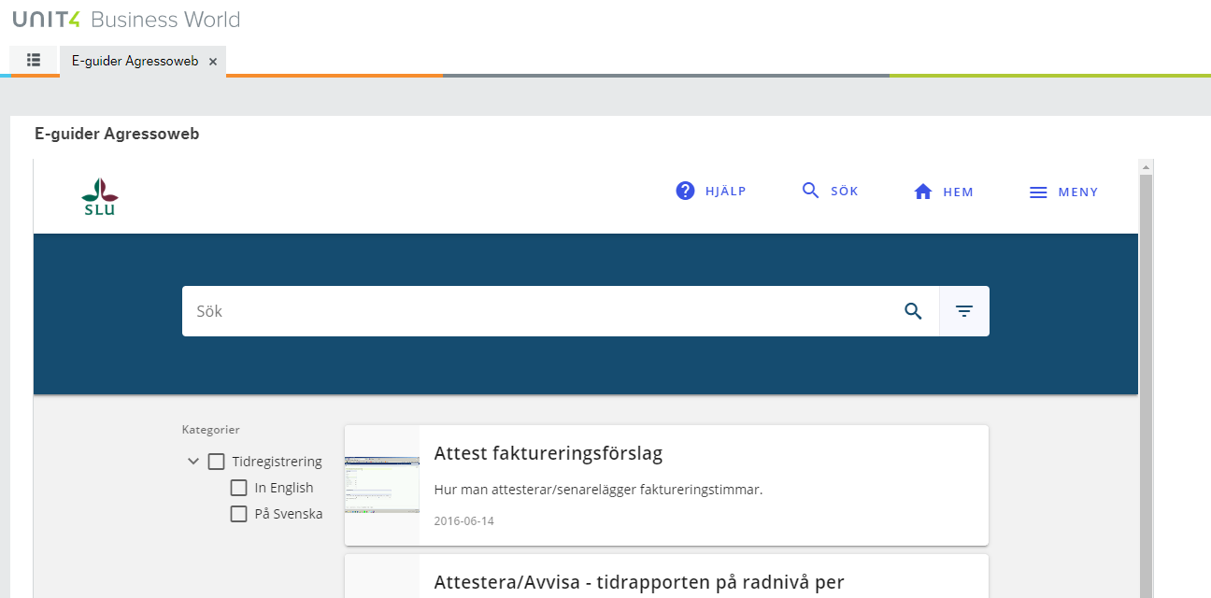
- This manual you will find under the heading ”Manuals registering time” who is a link to our staff web where all the manuals related to time registration can be found.
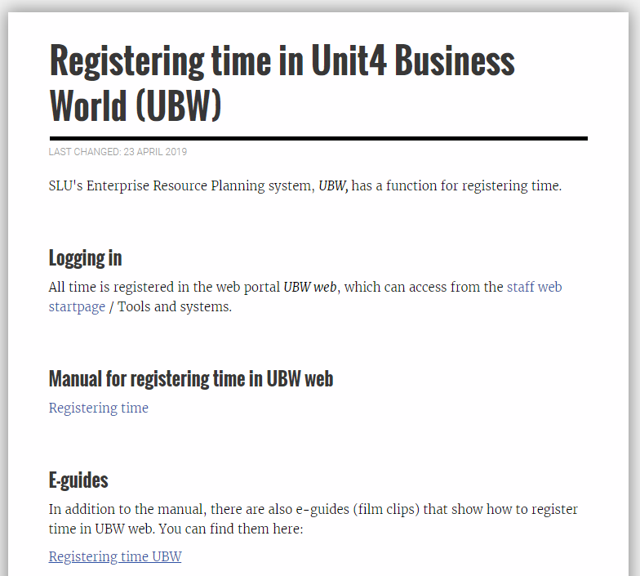
Common (Gemensam)
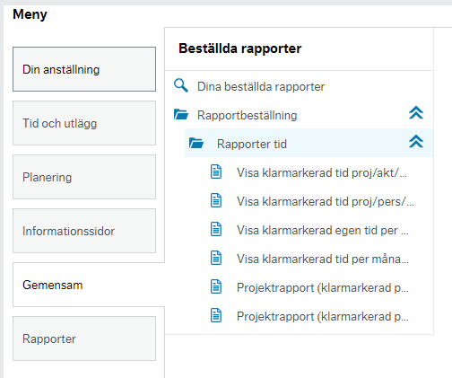
Excel reports are found under the menu Common if you have access to those reports.
Reports
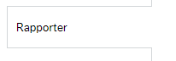 | 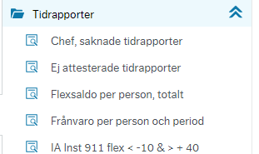
Depending on which department you belong to, you may have access to the menu Reports. Which reports you have access to also depend on which department you belong to.

Multiple tabs
Each page opens as a separate tab, allowing you to work with multiple pages at the same time.
In the example below, three pages are open: Timesheets-standard, Your timesheet details and Your balances.
To access the main menu, click the leftmost tab.
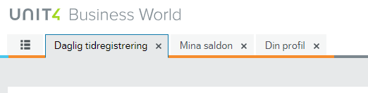

Your timesheet explained
Click on Timesheet – standard under the menu Time and expenses.
Explanation of the fields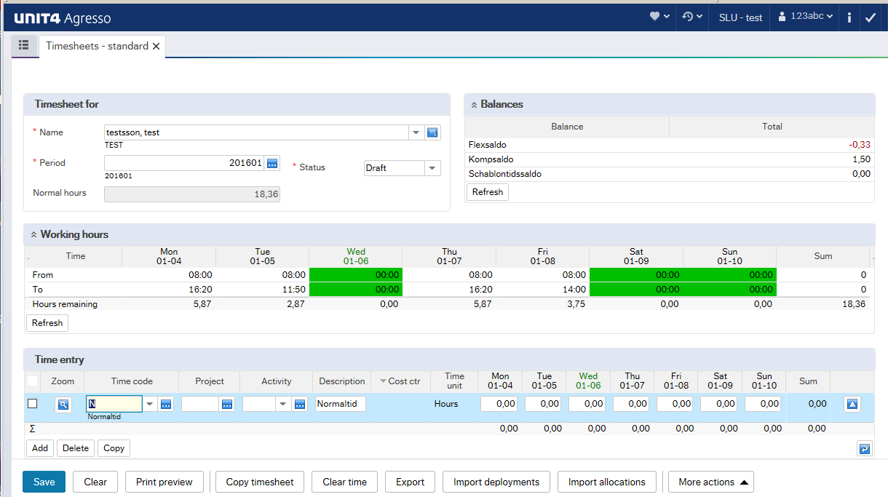
1
2
3
4
- Timesheet for
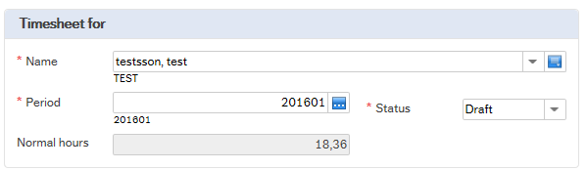
Name: Who the timesheet applies to.
Period: Which week (YYYYWW) you will register time for.
Normal hours: The number of working hours according to the schedule of the selected week.
Status: Draft or Ready depending on whether you are working on the timesheet or not.

- Balances
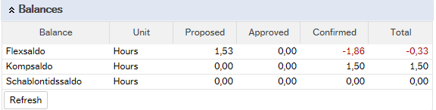
Here you see your balances for
Flex = flexitime (the time between your schedule and working time)
Kompsaldo = Balance you have received when you have worked overtime or add hours.
Schablontidssaldo = standard (schablon) time. Dep 135 can receive additional compensation based on different types of assignments.

The number of columns shown will vary depending on the department.
Explanation of the columns:
Proposed = hours not validated or transferred
Approved = hours validated but not transferred
Confirmed = hours validated and transferred
Total = the total balance for each type.

- Working hours
Here you can see the number of hours per day according to your schedule. 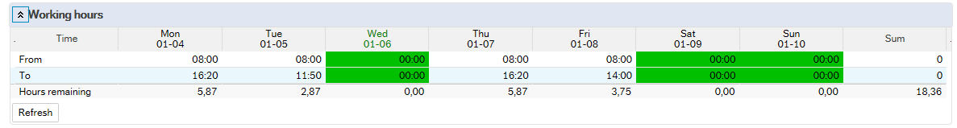

- Time entry
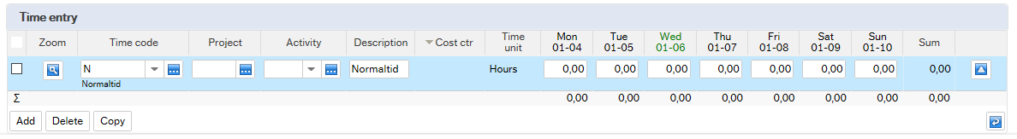
Here, you register your hours in hundredths, not in minutes.

Crib sheet, minutes translated into hundredths
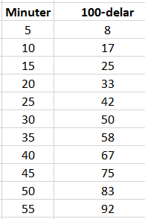

Working hours
In the middle of the page you will see the field Working hours. If you want to see your working hours per day, click the down arrow to the left of the header.
See the guide Time registration http://www.guider.nu/slu/484.guide, if you want to know how this field works during registration.

Register time
The easiest way to move between fields is to use the Tab key.
How to register time is described in the guide Time registration http://www.guider.nu/slu/484.guide.
Fields and buttons are explained in Time registration – explanation fields and buttons, http://www.guider.nu/slu/480.guide.
When you open the standard timesheet, your name is already filled in.
Choose the week in the field Period, as default current week will be displayed.
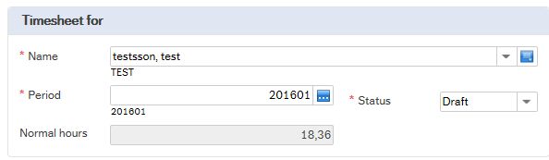
If you do not know which week you are looking for, you can search by using the field help. Klick the box to the right of the field. If you need more help, see the guide Different search options http://www.guider.nu/slu/486.guide.
Normal hours shows how many hours you should work during the chosen week. Do not change the status from draft until everything has been filled in.
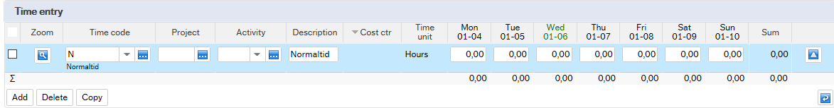
Initially, your time entry will have no lines. Start by clicking the Add button on the left.
If you need more lines, click the Add button again. The other buttons are described in this guide: http://www.guider.nu/slu/480.guide.
If you need help on how to search for available codes, please see the guide Different search options: http://www.guider.nu/slu/486.guide.
The following codes must always be filled in:

Time codes
Time code = the default is “N” (normal hours) and this is the correct code for all your normal working hours.
For overtime, additional hours, standard (schablon) time and compensatory leave you must use special time codes, see the section “Types of hours” (dep 135 must uses additional time codes for absences).
If you need another time code, you can type it directly into the Time code field, or search for possible values. For more information, see the guide Different search options.

Project/Work order
One of these fields will be visible, which one depends on which department you belong to. The field must be filled in.
You can fill it in manually, or you can search for the number using the button to the right of the project box. You can also use the scroll bar if that is accessible. If you need more help, please see the guide Different search options.

Activity
Activity should always be filled in. You can only choose an activity linked to the project/work order you entered in the previous step.
You can fill it in manually, or you can search for the number using the button to the right of the project box. You can also use the scroll bar if that is accessible. If you need more help, please see the guide Different search options.

Cost centre
The cost centre will be filled in automatically, and can only be changed if a project has several cost centres linked to it, and if the field is available for editing.
NB: If you want to enter another cost centre for the project than the default, you must change this before you change the status of the time report. Fill in the correct cost centre, or search for a valid one using the button to the right of the cost centre box.

Time unit
The last step is to add your hours for each date for the selected project /work order.

Time report status
As long as you need to make changes to your time report, you MUST leave it in draft status. Only change the status to Ready when you know that you will not need to make any more changes.

Saving the time report
You must always save your report using the Save button, which you will find to the left at the bottom of the tab. If you do not save, any changes you have made will be lost. The other buttons are explained in the guide Time registration – explanation fields and buttons, http://www.guider.nu/slu/480.guide.
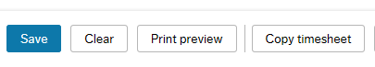

Flexitime
If your total number of registered hours differs from the standard working time according to your schedule, ERP will calculate a flexitime balance. A new line will be created in your report when you save it, provided you have change the status to Ready.
You can update your current flexitime balance by clicking the Refresh button.

Approval
When you have changed the status of the time report to Ready and saved it, the hours of that week will be forwarded for approval.
As long as a week has the status Ready or Draft you can still make changes to it. Once the status has changed to Transferred you need to contact your administrator if you need to change anything, or make the correction in the report for another week.
Make sure you enter a comment explaining why the correction has been made. Transactions that have already been approved will be greyed out and cannot be corrected. Instead, add a new line.

Create a weekly report template
If you work on the same projects every week, or if you have a yearly plan for which projects/work orders you will be working on, you can create a weekly report template that contains the combinations you think you will need during the year.
You then add hours for the projects/activities you have been working on before you save. How to save a report is described in the section ”Register time”.
When you have filled in your hours, there will probably be some lines without any hours registered that is with the value 0. These will not be sent for approval, but the person validating your report will see them as greyed out lines.

Copy an existing report
If you have created a weekly template, or if you want to base a report on a previously registered week, you start by selecting the period you want to register hours for.
Then click the Copy timesheet button at the bottom of the page.
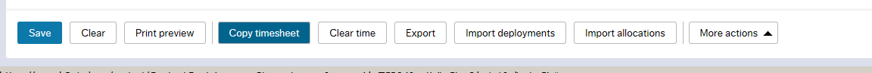
A box opens where you can select the period you created the weekly template for, or another previously registered week. NB: Make sure the box Clear time is always ticked to make sure no registered hours are transferred when you reuse the week. Finish by clicking OK. You can now add your hours. If you need to add new projects/activities, use the Add button. For more help, see the guide Register time based on a copied timesheet, http://www.guider.nu/slu/483.guide.
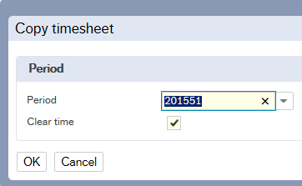

Rejected report
If the validator believes hours have been wrongly registered, he/she can reject either the report as a whole, or one or more lines in it. If your report, or parts of it, has been rejected, you will receive a mail informing you about this. Log into ERP Web and open the rejected entry by clicking first the tick mark, then the link in the box that appears:

How to correct a rejected report is described in the guide, Rejected timesheet, http://www.guider.nu/slu/482.guide.

Types of hours

Normal working hours
Normal working hours should ALWAYS be registered using the code ’N’ followed by project/work order, activity and cost centre (filled in automatically).

Absence (not comp leave)
How you register comp leave depends on which department you belong to.
These hours are not transferred to Primula. This means that you also need to register them using Primula self-service.

Department of Aquatic Resources
Staff at the Department of Aquatic Resources should use two different codes for leave, FRAN or SEM. Any other codes are filled in automatically.

Other departments
Staff at other departments use the code ’N’, normal working hours, followed by the project/work order for the department. Then select the activity that best matches the type of absence.
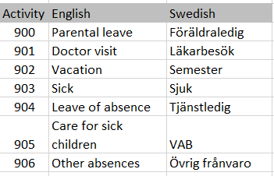

Comp leave
Before you register any comp leave, it must be approved in advance by your immediate superior.
Any hours registered as comp leave are transferred to Primula once a week, and you should not register them in Primula self-service as well.
There are three types of comp leave: normal comp leave, additional hours or standard (schablon) hours.
Each department has its own time codes to make sure the hours are registered for the correct department. Any other codes are filled in automatically.
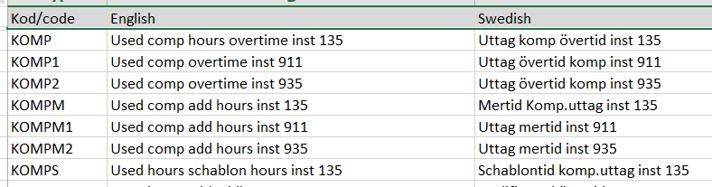
Registering overtime and additional hours will decrease the comp balance, and registering standard (schablon) hours will decrease the standard balance.

Overtime/Additional hours
All overtime or additional hours must be approved in advance by your immediate superior before you register them.
Hours registered as basic/qualified overtime will be transferred to Primula once a week. This means that you should not register these hours in Primula self-service as well.
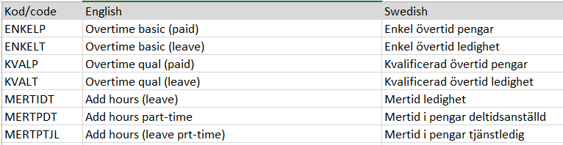

- ENKELP – Overtime basic (paid) - Enkel övertid pengar
- ENKELT – Overtime basic (leave) - Enkel övertid ledighet
- KVALP – Overtime qual (paid) - Kvalificerad övertid pengar
- KVALT - Overtime qual (leave) - Kvalificerad övertid ledighet
- MERENK – Add hours, basic (paid)- Mertid enkel i pengar
- MERENKKOMP - Add hours, basic (leave) - Mertid enkel i ledighet
- MERKVL – Add hours, qual (paid) - Mertid kvalificerad i pengar
- MERKVLKOMP – Add hours, qual (leave) - Mertid kvalificerad i ledighet
All departments that can register overtime/additional hours use the same codes, see the table above. After selecting a code, fill in project/work order and activity. The cost centre is filled in automatically by ERP.

Basic overtime: Instructed overtime that takes place on weekdays before 10pm. 1 hour basic overtime is compensated as 1.5 hours, as time or additional pay, depending on the time code selected.

Qualified overtime: Instructed overtime that takes place on weekends and after 10pm on weekdays. 1 hour qualified overtime is compensated as 2 hours, as time or additional pay, depending on the time code selected.

Additional hours (basic/qualified): Instructed additional hours for those working part time. Additional hours are the time between your part time hours and ordinary working hours for full time workers. The distinction between basic and qualified Additional hours follows the same rules as basic and qualified overtime.

Standard reimbursement (only for the Department of Aquatic Resources)
Register the number of hours for the mission. (If a mission lasts less than six hours, half of the total number of hours will be reimbursed). The code set is the same as for the National Board of Fisheries.
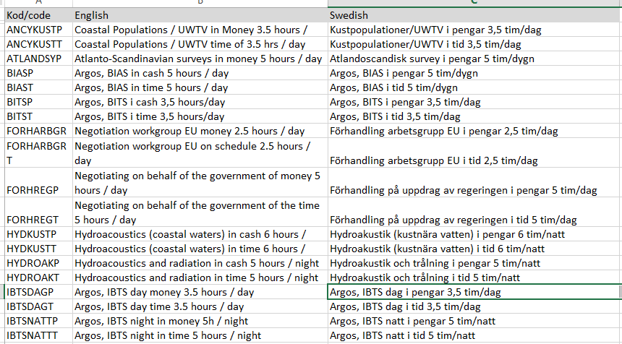
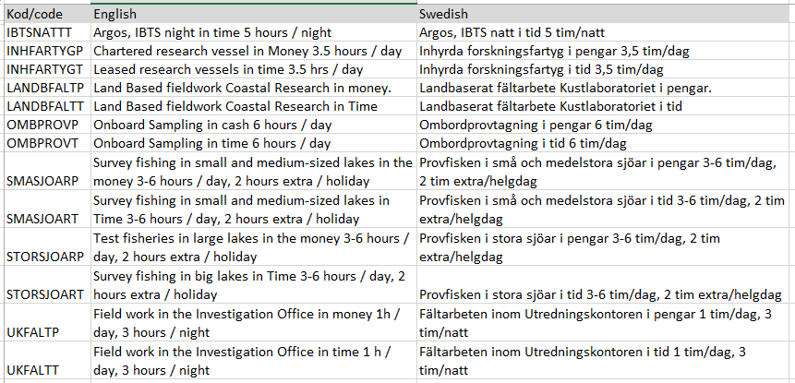

Flexitime
This is automatically calculated by ERP when you change the status to READY.

