cOurse syllabus template
7 November 2025

Please read and follow the instructions for course syllabuses before filling in the template. Fields marked * are compulsory. Select an option from the drop-down list, or type under the heading. Some of the headings are accompanied by a text box with notes such as this one. The course syllabus also contains some standardised text that will be automatically displayed in a red box on the course page. They are only included to show the final layout on the course page. Do not enter this text into the template manually, otherwise it will be entered into Ladok and displayed twice. SLU is a public authority and Swedish is its official language. Course syllabuses are a legally binding document and must therefore be written in Swedish. SLU rules stipulate that an English translation of a course syllabus is to be made available, although this version is not legally binding. See pages 2 and 3 of the instructions. Course syllabus templates are available in Swedish and English. The free-text fields in the Swedish version include bilingual headings to facilitate translation. The English template is monolingual.

Swedish course name* (Max. 100 characters)

English course name* (Max. 100 characters)

Course scope (credits)*

Responsible department*
Select a department.

Valid from*
Select a semester.

Grading scale*
Select an option.

Main field of study/subject*
You must choose either a main field of study or a subject. An additional main field of study or subject may be included for courses with a double classification. The level (cycle) and specialisation must be stated for main fields of study. See page 5 of the instructions.

Main field of study: Select main field of study
Additional main field, if applicable: Select main field of study
Level and specialisation: Select level and specialisation.
Subject: Select a subject.

A specialisation or sub-area must be stated below if biology and forestry science are the main fields of study. See Subject descriptions, and page 6 of the instructions.
Biology specialisation, if applicable
Select a biology specialisation.

Forestry science sub-area, if applicable

Language of instruction*
Select language.

See pages 7 and 13 of the instructions, for examples of how to formulate requirements.
Entry requirements*

You can write a brief description of the purpose of the course under before stating the set learning objectives as bullet points. See page 9 of the instructions.
Objectives*

Upon successful completion of the course, students will be able to:

Briefly describe the course content, regarding both subject-related content and teaching formats. See pages 10 and 16 of the instructions.
Content*
Subject-related content

Teaching formats
To further student learning and promote discussion, a variety of methods are used, such as:

The course focuses on the following generic skills:

Collaboration with the surrounding community takes place through:

State how the assessments will take place and any other conditions for passing the course (e.g., passing compulsory components). See pages 10 and 17 of the instructions.
Examination formats

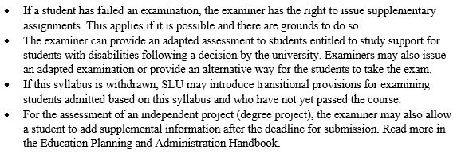

The course webpage contains important information that is not formally included in the course syllabus. See page 11 of the instructions.

Supplementary course information
Jointly responsible department(s), if applicable

Replaces (Course code(s) partly or entirely replaced by this course)

Additional information

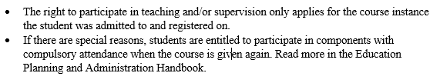

Course syllabus written by (Name and email address)

