Platta_rod_ logo2.eps

**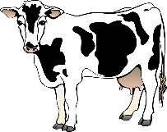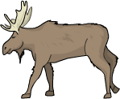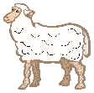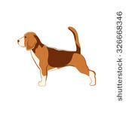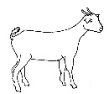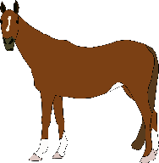**

**Certificate of Practical skills   
Animal species: ………..…………..………   
used for scientific or educational purposes**

**This is to certify that**:

Name (First name Surname): ………………………………………………………

Born (YYYYMMDD): …………………………………………………………………  
  
► Has demonstrated skills and competence in performing the following practical tasks/procedures;

|  |
| --- |
| ♦ Handling, moving and restraining (if relevant) |
| ♦ Assessment of behaviour - signs of pain and distress |
| ♦ Clinical examination (body temp., heart rate, breathing, mucus membranes etc) |
| ♦ |
| ♦ |
| ♦ |
| ♦ |
| ♦ |
| ♦ |

► Has been able to verbally explain the different ways to administer substances and collect blood and tissue samples and give an account of the pros and cons of the different methods.

Department of…………………….. Approved Practical Training by: ………………………………………  
……………………………………... ………………………………………  
Swedish University of *Signature*  
Agricultural Sciences  
 Date (YYYYMMDD)……………….

Name:………………………………..