Department of Animal Breeding and Genetics
[Ev. kompletterande text,
t.ex. befattningshavare]

Towards sustainable livestock systems

Stanley Zira’s dissertation Sept 16, 9.15, Audhumbla, VHC, Ultuna

Stanley Zira from the Dept of Animal Breeding and Genetics (HGEN) at SLU, will present and defend his doctoral thesis Towards sustainable livestock systems: Developing and applying methods for broad sustainability assessment of pig and cattle systems. The opponent is Thomas Nemecek from Agroscope in Switzerland and the examining committee consists of Elisabeth Ekener, Nick Holden, Rebecka Westin, Jan Tind Sörensen and Bente Aspeholmen Åby.

HGEN and Stanley’s supervisors Lotta Rydhmer, Elin Röös, Emma Ivarsson and Ruben Hoffmann welcome you to the dissertation. For those participating at campus, a light lunch will be served at VHC after the dissertation. You can also follow the dissertation on-line via this link: https://slu-se.zoom.us/j/69876637901 with passcode 561039.

Let us know if you will come to the dissertation and the light lunch by sending an email to caroline.jansson@slu.se, before Sept 12. Please indicate allergies and food preferences.

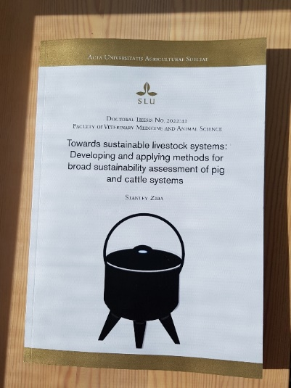

You find the thesis here: https://pub.epsilon.slu.se/28531/

For information about the dissertation, contact Lotta.Rydhmer@slu.se,
and for information about the PhD project, contact Stanley.Zira@slu.se

