Install applications through Software Center
To start Software Center, go to the Windows start menu, search for the application by typing “software canter” the search field, then click on the program.

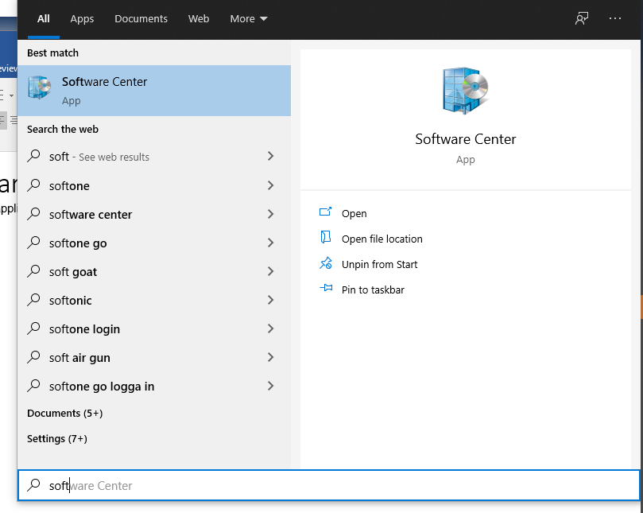

When the program started, you will find all programs under the Applications tab

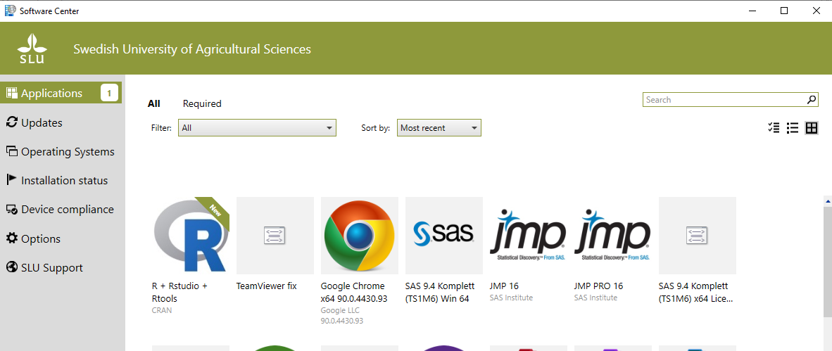

Select the application and then click Install.

You can follow the status of the installation under the Installation Status tab and when it is finished, you will also see that it appears there.

If you have problems installing the application, contact IT support:
Tfn: 018-67 6600
Epost: itstod@slu.se
Medarbetarwebben: Support request via web

